SPH 4UI Taming the Particle Zoo Lab Assignment

Unit: Energy & Momentum
Due: Thurs, March 4th at 8:30 AM

This lab activity is taken from the Perimeter Institute’s secondary school physics resource package: Remodelling Particle Physics.
Make a copy of this Google Doc and paste images of your work in the appropriate question. This will be evaluated as a summative assessment for the energy and momentum unit. It will be evaluated using levels.
Your submission for this assessment has the same academic integrity standards as all unit summative assessments for this course.
Be sure to remember to include your name at the top of each page. All written work should be proof-read and should be in full sentences.

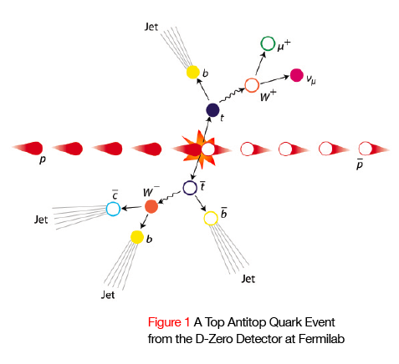
In 1995, Fermilab discovered evidence for the sixth and final quark of the Standard Model. This was done by accelerating and colliding protons and antiprotons together to form a top quark and an antitop quark. The energy of the protons was converted into the mass of the quarks via E = mc². The two quarks cannot be detected directly because they decay immediately into other particles. In this activity, you will use the momentum and energy of the decay particles to determine the mass of the original pair.

Part A: Top Quark
01. Protons and antiprotons were accelerated to equal and opposite speeds of over
99% of the speed of light. When they collided, as shown in Figure 1, the following
interactions occurred:
- They annihilated and produced a top-antitop pair with almost no momentum.
- This quark pair decayed almost immediately into lighter particles with lots of
momentum which moved approximately at right angles to the original proton beams.
- Three of these particles continued to decay into other particles, producing four
“jets” that were measured in the inner sections of the detector.
- The fourth particle decayed into a muon that was detected in the
outer part of the detector and a neutrino that was not detected.

02. Figure 2 shows an event display from one of these collisions. First print, or trace, Figure 2 onto a sheet of paper such that the length of the sample vector is about 9.5 cm long (you will need a ruler). Draw the horizontal and vertical components for each of the five labelled momentum vectors. Measure the length of each vector and each component. Record these lengths in the table below (the first one has been done as an example). Add the numbers in each direction and then convert these lengths to momentum units, using the scale:
1 mm = 1 GeV/c.

Magnitude  (mm) | 95.5 |  |  |  |  | Total  (mm) | Total  (GeV/c)
Horizontal  (mm) | -94
Vertical  (mm) | -14

03. The momentum vectors do not add up to zero. Conservation of momentum demands that the initial and final momenta must be equal.
D-Zero detects most particles, but neutrinos slip through unobserved. Use conservation of momentum to determine the momentum of the missing neutrino. Draw this momentum on the event display. Be sure to show any work you do and clearly label your momentum vector for the missing neutrino.

04. The equation E = mc² is for a particle at rest. The full equation is E² = (pc)² + (mc²)², where p is the relativistic momentum of the particle. The top and antitop quarks decay and produce jets of high-momentum particles. The momenta of these particles is so large that we can ignore the (mc²)² term here and the equation can be simplified to E = pc. This means that a small particle with 95.5 GeV/c of momentum has 95.5 GeV of energy. Find the total energy of all of the particles, including the neutrino, by adding their energies. (Remember that energy is added as a scalar, not a vector.) Show all your work in the space below...communication is important...think about how you would communicate your work to someone who doesn’t understand the question.

05. The energy released by the collision of the proton and antiproton is just enough to produce a top-antitop pair that is at rest in this particular, carefully-chosen event. The momentum of the top-antitop pair is extremely small compared to their mass-energy. The first term in E² = (pc)² + (mc²)² vanishes and the equation simplifies to E = mc². Use this to find the mass of a top quark. Show all your work in the space below and again, communicate your work/steps as if you were explaining them to someone else.

06. In order to find the top quark, Fermilab collided a proton and an antiproton together at very high speeds. You have a friend who studies biology. Your friend thinks that this is a rather sloppy way to dissect protons to see what is inside them. Explain to your friend how this collision is not like a dissection. Be sure to refer to the masses of protons (0.938 GeV) and top quarks (172 GeV).

